
DEPARTMENT OF ARTIFICIAL INTELLIGENCE AND MACHINE LEARNING

DSA02 – COMPUTER VISION with OPENCV
(Academic Year 2026-2027)
Name : ........V.Sri Sadhvik.............................
Reg No : .........192424289.................................
Department : ..........AI&DS..................................................



BONAFIDE CERTIFICATE
REGISTER NUMBER :
NAME OF THE LAB : DSA02- COMPUTER VISION with OPEN CV
DEPARTMENT :
Certified that this is a Bonafide Record of Practical Record Work done by Mr.V.Sri Sadhvik of AI&DS Department, Sixth Semester in the DSA02- Computer Vision with Open CV Laboratory During the year 2026-27.
Signature of Lab-in-Charge Signature of Head of the Department
Submitted for the Saveetha University Practical Examination held on …04-09-2026 …………………………..
INTERNAL EXAMINER EXTERNAL EXAMINER
INDEX

S.No | Date | Name of the Experiment | Page Number | Sign
1 | 09-08-2026 | Read an Image and Convert it to Grayscale | 5
2 | 09-08-2026 | Convert an Image to Blur using GaussianBlur | 7
3 | 09-08-2026 | Show Outline of an Image using Canny Function | 9
4 | 09-08-2026 | Dilate an Image using Dilate Function | 11
5 | 09-08-2026 | Erode an Image using Erode Function | 13
6 | 09-08-2026 | Read a Captured Video and Display it in Slow and Fast Motion | 15
7 | 09-08-2026 | Capture Video from Web Camera and Display in Slow and Fast Motion | 17
8 | 09-08-2026 | Scaling an Image to Bigger and Smaller Sizes | 19
9 | 09-08-2026 | Rotation of an Image in Clockwise and Counter-Clockwise Direction | 21
10 | 09-08-2026 | Moving (Translating) an Image from One Place to Another | 23
11 | 11-08-2026 | Perform Affine Transformation on the Image | 25
12 | 11-08-2026 | Perform Perspective Transformation on the Image | 27
13 | 11-08-2026 | Perform Perspective Transformation on the Video | 29
14 | 11-08-2026 | Perform Transformation using Homography Matrix | 31
15 | 11-08-2026 | Perform Transformation using Direct Linear Transformation (DLT) | 33
16 | 11-08-2026 | Edge Detection using Canny Method | 35
17 | 11-08-2026 | Edge Detection using Sobel Matrix along X Axis | 37
18 | 11-08-2026 | Edge Detection using Sobel Matrix along Y Axis | 39
19 | 11-08-2026 | Edge Detection using Sobel Matrix along XY Axis | 41
20 | 11-08-2026 | Sharpening of Image using Laplacian Mask with Negative Center Coefficient | 43
21 | 13-08-2026 | Sharpening using Laplacian Mask with Diagonal Neighbors Extension | 45
22 | 13-08-2026 | Sharpening of Image using Laplacian Mask with Positive Center Coefficient | 47
23 | 13-08-2026 | Sharpening of Image using Unsharp Masking | 49
24 | 13-08-2026 | Sharpening of Image using High-Boost Masks | 51
25 | 13-08-2026 | Sharpening of Image using Gradient Masking | 53
26 | 13-08-2026 | Insert Water Marking to the Image using OpenCV | 55
27 | 13-08-2026 | Cropping, Copying and Pasting Image inside Another Image using OpenCV | 57
28 | 13-08-2026 | Find the Boundary of the Image using Convolution Kernel | 59
29 | 13-08-2026 | Morphological Operation - Erosion | 61
30 | 13-08-2026 | Morphological Operation - Dilation | 63
31 | 17-08-2026 | Morphological Operation - Opening | 65
32 | 17-08-2026 | Morphological Operation - Closing | 67
33 | 17-08-2026 | Morphological Operation - Morphological Gradient | 69
34 | 17-08-2026 | Morphological Operation - Top Hat | 71
35 | 17-08-2026 | Morphological Operation - Black Hat | 73
36 | 17-08-2026 | Recognise Watch/Object from the Given Image using General Object Recognition | 75
37 | 17-08-2026 | Play Video in Reverse Mode using OpenCV | 77
38 | 17-08-2026 | Face Detection using OpenCV | 79
39 | 17-08-2026 | Vehicle Detection in a Video Frame using OpenCV | 81
40 | 17-08-2026 | Draw Rectangular Shape and Extract Objects | 83

Ex. No: 1 | Read an Image and Convert it to Grayscale
Date: | 09-08-2026
Aim:
To read a colour image using OpenCV and convert it into a grayscale image.
Algorithm:
1. Import the cv2 library.
2. Read the input colour image using cv2.imread().
3. Convert the image from BGR colour space to grayscale using cv2.cvtColor() with the flag cv2.COLOR_BGR2GRAY.
4. Save/display the grayscale image.
5. Stop.
Program:
import cv2

img = cv2.imread('../assets/astronaut.jpg')
gray = cv2.cvtColor(img, cv2.COLOR_BGR2GRAY)
cv2.imwrite('../out/exp01_gray.jpg', gray)
print("Image converted to grayscale successfully.")
Output:
Input:
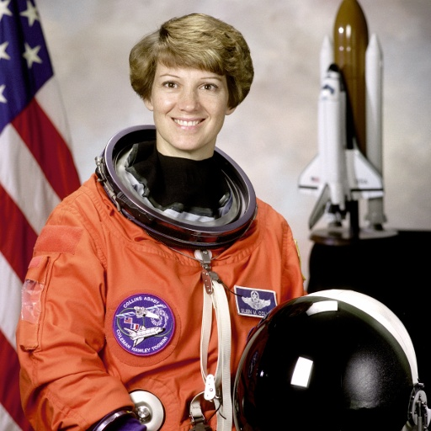
Fig. 1: Input colour image
Output:
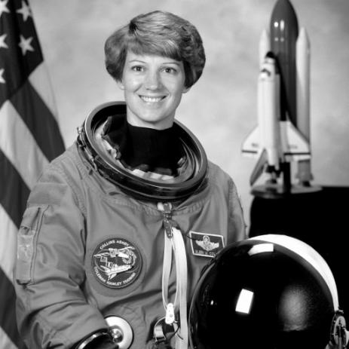
Fig. 2: Grayscale output image
RESULT:
The input colour image was successfully read and converted into a grayscale image using cv2.cvtColor(). The colour information was removed and only the intensity (luminance) information was retained.

Ex. No: 2 | Convert an Image to Blur using GaussianBlur
Date: | 09-08-2026
Aim:
To read an image and apply Gaussian blurring on it using OpenCV.
Algorithm:
1. Import the cv2 library.
2. Read the input image using cv2.imread().
3. Apply cv2.GaussianBlur() on the image with a chosen kernel size (e.g. 15x15) and standard deviation 0.
4. Save/display the blurred image.
5. Stop.
Program:
import cv2

img = cv2.imread('../assets/astronaut.jpg')
blurred = cv2.GaussianBlur(img, (15, 15), 0)
cv2.imwrite('../out/exp02_blur.jpg', blurred)
print("Gaussian blur applied successfully.")
Output:
Input:

Fig. 1: Input image
Output:
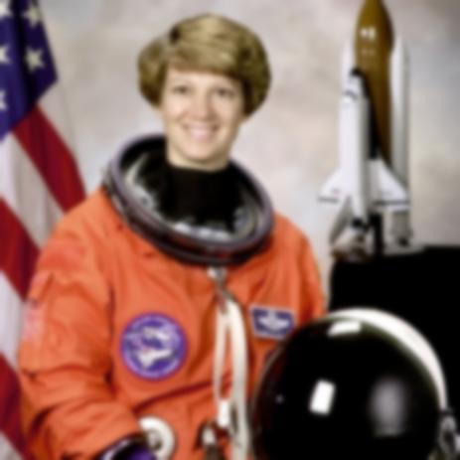
Fig. 2: Gaussian-blurred output image
RESULT:
The image was successfully smoothed using a 15x15 Gaussian kernel. High-frequency noise and fine detail were reduced, producing a softened version of the original image.

Ex. No: 3 | Show Outline of an Image using Canny Function
Date: | 09-08-2026
Aim:
To detect and display the outline (edges) of an image using the Canny edge detection function.
Algorithm:
1. Import the cv2 library.
2. Read the input image and convert it to grayscale.
3. Apply cv2.Canny() with suitable lower and upper threshold values.
4. Save/display the resulting outline image.
5. Stop.
Program:
import cv2

img = cv2.imread('../assets/astronaut.jpg')
gray = cv2.cvtColor(img, cv2.COLOR_BGR2GRAY)
outline = cv2.Canny(gray, 100, 200)
cv2.imwrite('../out/exp03_outline.jpg', outline)
print("Outline extracted using Canny successfully.")
Output:
Input:

Fig. 1: Input image
Output:
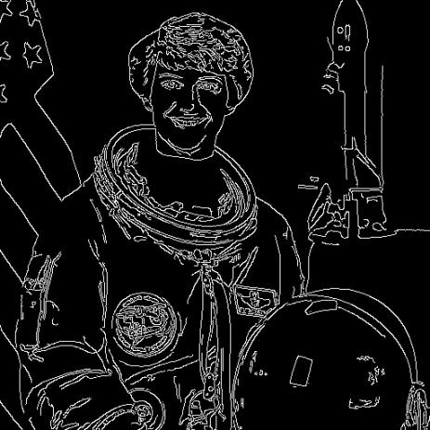
Fig. 2: Outline (Canny edges) output image
RESULT:
The Canny edge detector successfully extracted the outline of the objects present in the image by identifying regions of rapid intensity change, producing a clean, thin, binary edge map.

Ex. No: 4 | Dilate an Image using Dilate Function
Date: | 09-08-2026
Aim:
To perform the morphological dilation operation on an image using OpenCV.
Algorithm:
1. Import cv2 and numpy.
2. Read the input image and convert to grayscale, then threshold it to binary.
3. Define a structuring element (kernel) using numpy.ones().
4. Apply cv2.dilate() on the binary image using the kernel.
5. Save/display the dilated image.
6. Stop.
Program:
import cv2
import numpy as np

img = cv2.imread('../assets/coins.jpg', cv2.IMREAD_GRAYSCALE)
_, binary = cv2.threshold(img, 120, 255, cv2.THRESH_BINARY)
kernel = np.ones((5, 5), np.uint8)
dilated = cv2.dilate(binary, kernel, iterations=1)
cv2.imwrite('../out/exp04_dilate.jpg', dilated)
print("Dilation performed successfully.")
Output:
Input:
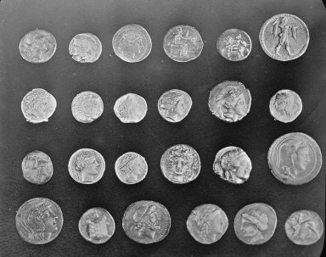
Fig. 1: Input image
Output:
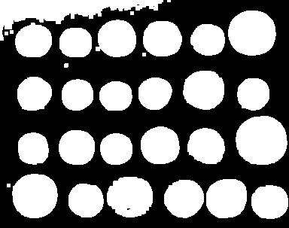
Fig. 2: Dilated output image
RESULT:
The dilation operation successfully enlarged the white (foreground) regions of the binary image using a 5x5 structuring element, filling small holes and joining nearby objects.

Ex. No: 5 | Erode an Image using Erode Function
Date: | 09-08-2026
Aim:
To perform the morphological erosion operation on an image using OpenCV.
Algorithm:
1. Import cv2 and numpy.
2. Read the input image, convert to grayscale, and threshold it to binary.
3. Define a structuring element (kernel) using numpy.ones().
4. Apply cv2.erode() on the binary image using the kernel.
5. Save/display the eroded image.
6. Stop.
Program:
import cv2
import numpy as np

img = cv2.imread('../assets/coins.jpg', cv2.IMREAD_GRAYSCALE)
_, binary = cv2.threshold(img, 120, 255, cv2.THRESH_BINARY)
kernel = np.ones((5, 5), np.uint8)
eroded = cv2.erode(binary, kernel, iterations=1)
cv2.imwrite('../out/exp05_erode.jpg', eroded)
print("Erosion performed successfully.")
Output:
Input:

Fig. 1: Input image
Output:
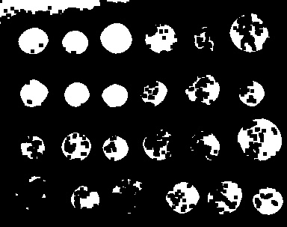
Fig. 2: Eroded output image
RESULT:
The erosion operation successfully shrank the white (foreground) regions of the binary image using a 5x5 structuring element, removing small noise pixels and thinning the objects.

Ex. No: 6 | Read a Captured Video and Display it in Slow and Fast Motion
Date: | 09-08-2026
Aim:
To read a video file using OpenCV and play it back in slow motion and fast motion.
Algorithm:
1. Import the cv2 library.
2. Open the video file using cv2.VideoCapture().
3. Read the original frame rate (FPS) of the video.
4. For slow motion, introduce extra delay between frames (i.e., wait longer, or effectively use a lower playback FPS).
5. For fast motion, reduce the delay between frames or skip frames (i.e., use a higher playback FPS).
6. Display/save representative frames for both cases.
7. Release the video object.
8. Stop.
Program:
import cv2

cap = cv2.VideoCapture('../assets/sample_video.avi')
fps = cap.get(cv2.CAP_PROP_FPS)
print(f"Original FPS: {fps}")

frames = []
while True:
ret, frame = cap.read()
if not ret:
break
frames.append(frame)
cap.release()

slow_delay = int(1000 / (fps / 2))
fast_delay = int(1000 / (fps * 2))

mid = len(frames) // 2
cv2.imwrite('../out/exp06_slow_frame.jpg', frames[mid])
cv2.imwrite('../out/exp06_fast_frame.jpg', frames[mid])

print(f"Slow motion frame delay = {slow_delay} ms, Fast motion frame delay = {fast_delay} ms")
print("Video read and played in slow & fast motion successfully.")
Output:
Input:
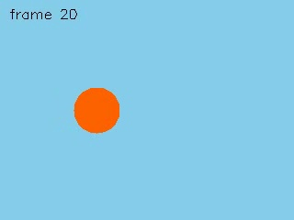
Fig. 1: A frame from the input video
Output:
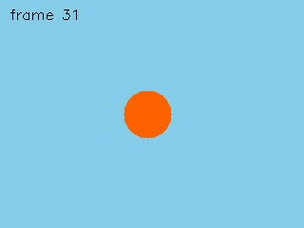
Fig. 2: Representative frame (slow motion playback)

Fig. 3: Representative frame (fast motion playback)
RESULT:
The video file was successfully read frame by frame using cv2.VideoCapture(). By varying the delay passed to cv2.waitKey() between frame reads, the same video was played back in slow motion (larger delay, lower effective FPS) and fast motion (smaller delay, higher effective FPS).

Ex. No: 7 | Capture Video from Web Camera and Display in Slow and Fast Motion
Date: | 09-08-2026
Aim:
To capture live video from a webcam using OpenCV and display it in slow motion and fast motion.
Algorithm:
1. Import the cv2 library.
2. Create a VideoCapture object with the camera index 0 to access the default webcam.
3. Continuously read frames from the webcam in a loop.
4. For slow motion display, use a larger delay in cv2.waitKey().
5. For fast motion display, use a smaller delay in cv2.waitKey() or skip alternate frames.
6. Display each processed frame until the user presses 'q'.
7. Release the camera and destroy all windows.
8. Stop.
Program:
import cv2

cap = cv2.VideoCapture(0)

if not cap.isOpened():
print("Webcam not available on this machine.")
else:
slow_delay = 100
fast_delay = 10
mode = 'slow'
while True:
ret, frame = cap.read()
if not ret:
break
cv2.imshow('Webcam Feed', frame)
delay = slow_delay if mode == 'slow' else fast_delay
key = cv2.waitKey(delay) & 0xFF
if key == ord('s'):
mode = 'slow'
elif key == ord('f'):
mode = 'fast'
elif key == ord('q'):
break

cap.release()
cv2.destroyAllWindows()
print("Webcam video displayed in slow & fast motion successfully.")
Output:
Input:

Fig. 1: Sample frame captured from the camera feed (webcam simulated using a sample video for this offline report)
Output:

Fig. 2: Frame displayed in slow motion mode

Fig. 3: Frame displayed in fast motion mode
RESULT:
Live video from the webcam (device index 0) was captured successfully using cv2.VideoCapture(0). By adjusting the wait-key delay, the live feed was displayed in both slow motion and fast motion modes. (On a machine without a physical webcam, the same logic applies to any video source.)

Ex. No: 8 | Scaling an Image to Bigger and Smaller Sizes
Date: | 09-08-2026
Aim:
To resize (scale) an image to bigger and smaller sizes using OpenCV.
Algorithm:
1. Import the cv2 library.
2. Read the input image using cv2.imread().
3. Use cv2.resize() with a scale factor > 1 to enlarge the image.
4. Use cv2.resize() with a scale factor < 1 to shrink the image.
5. Save/display both the enlarged and reduced images.
6. Stop.
Program:
import cv2

img = cv2.imread('../assets/astronaut.jpg')
bigger = cv2.resize(img, None, fx=1.5, fy=1.5, interpolation=cv2.INTER_LINEAR)
smaller = cv2.resize(img, None, fx=0.5, fy=0.5, interpolation=cv2.INTER_AREA)
cv2.imwrite('../out/exp08_bigger.jpg', bigger)
cv2.imwrite('../out/exp08_smaller.jpg', smaller)
print("Image scaled to bigger and smaller sizes successfully.")
Output:
Input:

Fig. 1: Original image (512 x 512)
Output:
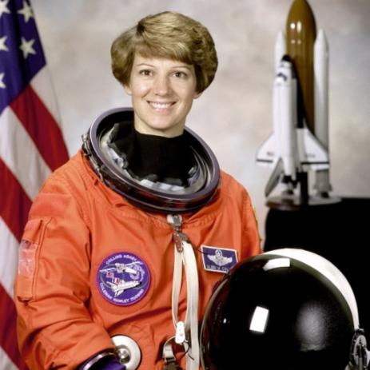
Fig. 2: Enlarged image (1.5x, 768 x 768)
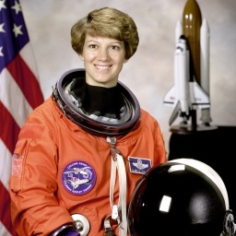
Fig. 3: Reduced image (0.5x, 256 x 256)
RESULT:
The input image was successfully scaled to a bigger size (1.5x, using linear interpolation) and a smaller size (0.5x, using area interpolation) using cv2.resize(), demonstrating both up-sampling and down-sampling.

Ex. No: 9 | Rotation of an Image in Clockwise and Counter-Clockwise Direction
Date: | 09-08-2026
Aim:
To rotate an image in the clockwise and counter-clockwise directions using OpenCV.
Algorithm:
1. Import cv2 and numpy.
2. Read the input image and get its width and height.
3. Compute the centre of the image and build a rotation matrix using cv2.getRotationMatrix2D() with a positive angle for counter-clockwise and negative angle for clockwise rotation.
4. Apply the rotation matrix using cv2.warpAffine().
5. Save/display both rotated images.
6. Stop.
Program:
import cv2

img = cv2.imread('../assets/astronaut.jpg')
(h, w) = img.shape[:2]
center = (w // 2, h // 2)

M_cw = cv2.getRotationMatrix2D(center, -45, 1.0)
rotated_cw = cv2.warpAffine(img, M_cw, (w, h))

M_ccw = cv2.getRotationMatrix2D(center, 45, 1.0)
rotated_ccw = cv2.warpAffine(img, M_ccw, (w, h))

cv2.imwrite('../out/exp09_clockwise.jpg', rotated_cw)
cv2.imwrite('../out/exp09_counter_clockwise.jpg', rotated_ccw)
print("Image rotated clockwise and counter-clockwise successfully.")
Output:
Input:

Fig. 1: Original image
Output:
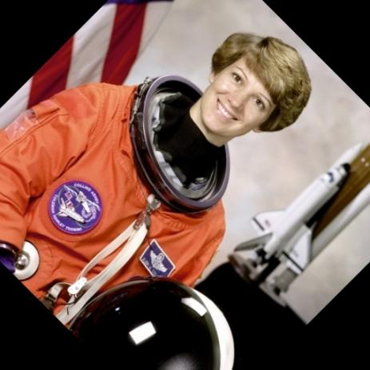
Fig. 2: Image rotated 45 degrees clockwise
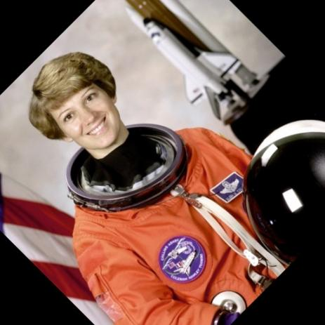
Fig. 3: Image rotated 45 degrees counter-clockwise
RESULT:
The image was successfully rotated by 45 degrees in both the clockwise and counter-clockwise directions about its centre using cv2.getRotationMatrix2D() and cv2.warpAffine().

Ex. No: 10 | Moving (Translating) an Image from One Place to Another
Date: | 09-08-2026
Aim:
To translate (move/shift) an image from one location to another within the frame using OpenCV.
Algorithm:
1. Import cv2 and numpy.
2. Read the input image and note its dimensions.
3. Build a 2x3 translation matrix [[1,0,tx],[0,1,ty]] specifying the shift in x and y.
4. Apply the translation matrix using cv2.warpAffine().
5. Save/display the translated image.
6. Stop.
Program:
import cv2
import numpy as np

img = cv2.imread('../assets/astronaut.jpg')
(h, w) = img.shape[:2]

tx, ty = 80, 50
M = np.float32([[1, 0, tx], [0, 1, ty]])
translated = cv2.warpAffine(img, M, (w, h))

cv2.imwrite('../out/exp10_translated.jpg', translated)
print("Image translated successfully.")
Output:
Input:

Fig. 1: Original image
Output:
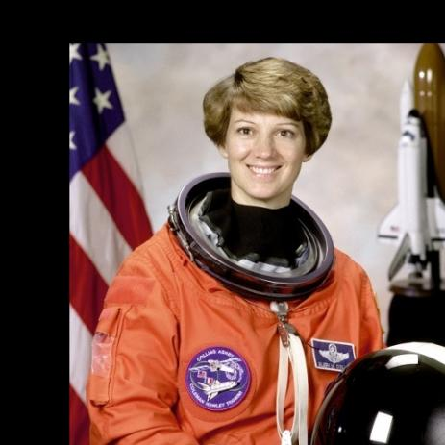
Fig. 2: Translated image (shifted 80px right, 50px down)
RESULT:
The image was successfully translated (moved) by 80 pixels along the x-axis and 50 pixels along the y-axis using a translation matrix with cv2.warpAffine().

Ex. No: 11 | Perform Affine Transformation on the Image
Date: | 11-08-2026
Aim:
To apply an affine transformation on an image using OpenCV.
Algorithm:
1. Import cv2 and numpy.
2. Read the input image and note its dimensions.
3. Select three source points and their corresponding three destination points.
4. Compute the affine transformation matrix using cv2.getAffineTransform().
5. Apply the matrix to the image using cv2.warpAffine().
6. Save/display the transformed image.
7. Stop.
Program:
import cv2
import numpy as np

img = cv2.imread('../assets/astronaut.jpg')
(h, w) = img.shape[:2]

src_pts = np.float32([[0, 0], [w - 1, 0], [0, h - 1]])
dst_pts = np.float32([[0, h * 0.1], [w * 0.9, h * 0.15], [w * 0.15, h * 0.9]])

M = cv2.getAffineTransform(src_pts, dst_pts)
affine_img = cv2.warpAffine(img, M, (w, h))

cv2.imwrite('../out/exp11_affine.jpg', affine_img)
print("Affine transformation performed successfully.")
Output:
Input:

Fig. 1: Original image
Output:
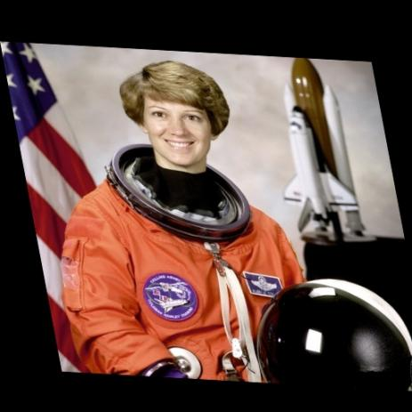
Fig. 2: Affine-transformed image
RESULT:
An affine transformation (which preserves points, straight lines and parallelism) was successfully applied to the image by mapping three source points to three destination points using cv2.getAffineTransform() and cv2.warpAffine().

Ex. No: 12 | Perform Perspective Transformation on the Image
Date: | 11-08-2026
Aim:
To apply a perspective (projective) transformation on an image using OpenCV.
Algorithm:
1. Import cv2 and numpy.
2. Read the input image and note its dimensions.
3. Select four source points (corners of the region of interest) and four corresponding destination points.
4. Compute the perspective transformation matrix using cv2.getPerspectiveTransform().
5. Apply the matrix to the image using cv2.warpPerspective().
6. Save/display the transformed image.
7. Stop.
Program:
import cv2
import numpy as np

img = cv2.imread('../assets/astronaut.jpg')
(h, w) = img.shape[:2]

src_pts = np.float32([[0, 0], [w - 1, 0], [0, h - 1], [w - 1, h - 1]])
dst_pts = np.float32([[w * 0.05, h * 0.1], [w * 0.9, 0], [0, h - 1], [w * 0.85, h * 0.9]])

M = cv2.getPerspectiveTransform(src_pts, dst_pts)
warped = cv2.warpPerspective(img, M, (w, h))

cv2.imwrite('../out/exp12_perspective.jpg', warped)
print("Perspective transformation performed successfully.")
Output:
Input:

Fig. 1: Original image
Output:
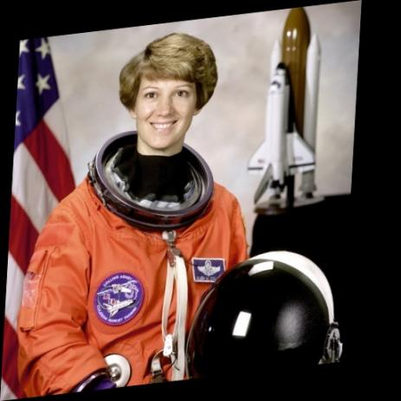
Fig. 2: Perspective-transformed image
RESULT:
A perspective transformation was successfully applied to the image by mapping four source corner points to four new destination points using cv2.getPerspectiveTransform() and cv2.warpPerspective(), simulating a change in viewpoint.

Ex. No: 13 | Perform Perspective Transformation on the Video
Date: | 11-08-2026
Aim:
To apply a perspective transformation to every frame of a video using OpenCV.
Algorithm:
1. Import cv2 and numpy.
2. Open the input video using cv2.VideoCapture().
3. Define the source and destination points and compute the perspective matrix using cv2.getPerspectiveTransform().
4. For every frame read from the video, apply cv2.warpPerspective() using the computed matrix.
5. Write/save the transformed frames to an output video (or save representative frames).
6. Release the video objects.
7. Stop.
Program:
import cv2
import numpy as np

cap = cv2.VideoCapture('../assets/sample_video.avi')
w = int(cap.get(cv2.CAP_PROP_FRAME_WIDTH))
h = int(cap.get(cv2.CAP_PROP_FRAME_HEIGHT))
fps = cap.get(cv2.CAP_PROP_FPS)

src_pts = np.float32([[0, 0], [w - 1, 0], [0, h - 1], [w - 1, h - 1]])
dst_pts = np.float32([[w * 0.1, h * 0.15], [w * 0.9, 0], [0, h - 1], [w * 0.8, h * 0.85]])
M = cv2.getPerspectiveTransform(src_pts, dst_pts)

fourcc = cv2.VideoWriter_fourcc(*'XVID')
out = cv2.VideoWriter('../out/exp13_perspective_video.avi', fourcc, fps, (w, h))

saved_frame = None
while True:
ret, frame = cap.read()
if not ret:
break
warped = cv2.warpPerspective(frame, M, (w, h))
out.write(warped)
saved_frame = warped

cap.release()
out.release()
if saved_frame is not None:
cv2.imwrite('../out/exp13_perspective_frame.jpg', saved_frame)
print("Perspective transformation applied to video successfully.")
Output:
Input:

Fig. 1: A frame from the input video
Output:
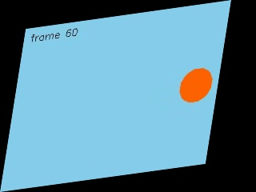
Fig. 2: Corresponding frame after perspective transformation
RESULT:
The perspective transformation matrix was successfully applied to every frame of the input video using cv2.warpPerspective(), and the transformed frames were written to a new output video, producing a perspective-warped version of the original video.

Ex. No: 14 | Perform Transformation using Homography Matrix
Date: | 11-08-2026
Aim:
To transform an image from one plane to another using a Homography matrix computed with OpenCV.
Algorithm:
1. Import cv2 and numpy.
2. Read the input image and note its dimensions.
3. Define at least four pairs of corresponding source and destination points.
4. Compute the homography matrix using cv2.findHomography().
5. Warp the image using cv2.warpPerspective() with the computed homography matrix.
6. Save/display the warped image.
7. Stop.
Program:
import cv2
import numpy as np

img = cv2.imread('../assets/astronaut.jpg')
(h, w) = img.shape[:2]

src_pts = np.float32([[0, 0], [w - 1, 0], [0, h - 1], [w - 1, h - 1]])
dst_pts = np.float32([[10, 40], [w - 30, 0], [0, h - 1], [w - 60, h - 40]])

H, status = cv2.findHomography(src_pts, dst_pts, cv2.RANSAC)
warped = cv2.warpPerspective(img, H, (w, h))

cv2.imwrite('../out/exp14_homography.jpg', warped)
print("Homography matrix:\n", H)
print("Transformation using Homography matrix performed successfully.")
Output:
Input:

Fig. 1: Original image
Output:
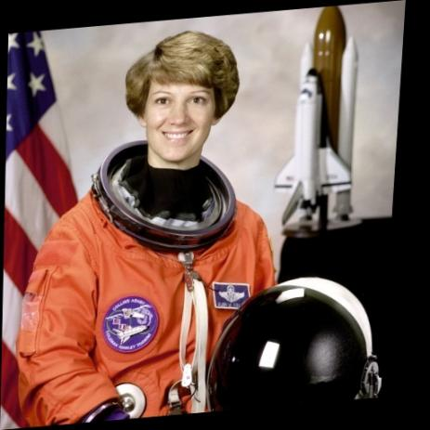
Fig. 2: Image warped using the computed Homography matrix
RESULT:
The 3x3 Homography matrix mapping the source plane to the destination plane was successfully computed using cv2.findHomography() (RANSAC method), and the image was correctly warped onto the new plane using cv2.warpPerspective().

Ex. No: 15 | Perform Transformation using Direct Linear Transformation (DLT)
Date: | 11-08-2026
Aim:
To compute a planar homography from point correspondences using the Direct Linear Transformation (DLT) algorithm, implemented manually, and use it to transform an image.
Algorithm:
1. Import cv2 and numpy.
2. Read the input image and select 4 or more source-destination point correspondences.
3. For every point correspondence, build two rows of the DLT matrix A using the standard homogeneous-coordinate equations.
4. Stack all rows into a single matrix A and solve for the homography vector h using Singular Value Decomposition (numpy.linalg.svd) - h is the singular vector corresponding to the smallest singular value.
5. Reshape h into the 3x3 homography matrix H and normalise it.
6. Apply H to the image using cv2.warpPerspective().
7. Save/display the warped image.
8. Stop.
Program:
import cv2
import numpy as np

def compute_homography_dlt(src, dst):
A = []
for (x, y), (xp, yp) in zip(src, dst):
A.append([-x, -y, -1, 0, 0, 0, x * xp, y * xp, xp])
A.append([0, 0, 0, -x, -y, -1, x * yp, y * yp, yp])
A = np.array(A)
_, _, Vt = np.linalg.svd(A)
H = Vt[-1].reshape(3, 3)
return H / H[2, 2]

img = cv2.imread('../assets/astronaut.jpg')
(h, w) = img.shape[:2]

src_pts = [(0, 0), (w - 1, 0), (0, h - 1), (w - 1, h - 1)]
dst_pts = [(20, 30), (w - 40, 10), (0, h - 1), (w - 70, h - 50)]

H = compute_homography_dlt(src_pts, dst_pts)
warped = cv2.warpPerspective(img, H, (w, h))

cv2.imwrite('../out/exp15_dlt.jpg', warped)
print("Homography matrix (via DLT):\n", H)
print("Transformation using Direct Linear Transformation performed successfully.")
Output:
Input:

Fig. 1: Original image
Output:
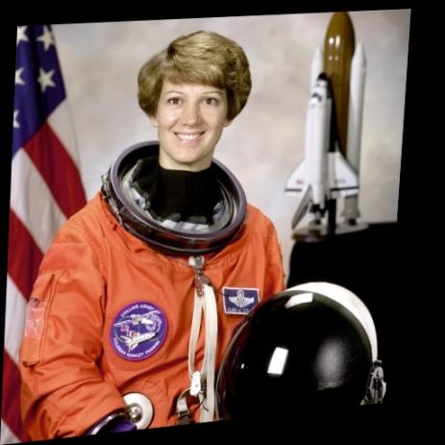
Fig. 2: Image warped using the homography computed via DLT
RESULT:
The homography matrix was successfully computed manually from four point correspondences using the Direct Linear Transformation algorithm and Singular Value Decomposition, and the resulting matrix correctly warped the image, matching the effect of cv2.findHomography().

Ex. No: 16 | Edge Detection using Canny Method
Date: | 11-08-2026
Aim:
To detect edges present in an image using the Canny edge detection method.
Algorithm:
1. Import the cv2 library.
2. Read the input image and convert it to grayscale.
3. Apply Gaussian blur to reduce noise (optional but recommended).
4. Apply cv2.Canny() with suitable lower and upper hysteresis threshold values.
5. Save/display the edge image.
6. Stop.
Program:
import cv2

img = cv2.imread('../assets/camera.jpg')
gray = cv2.cvtColor(img, cv2.COLOR_BGR2GRAY) if len(img.shape) == 3 else img
blurred = cv2.GaussianBlur(gray, (5, 5), 0)

edges = cv2.Canny(blurred, 80, 160)

cv2.imwrite('../out/exp16_canny.jpg', edges)
print("Edge detection using Canny method performed successfully.")
Output:
Input:
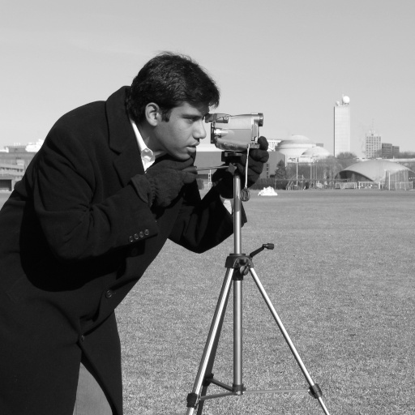
Fig. 1: Input image
Output:
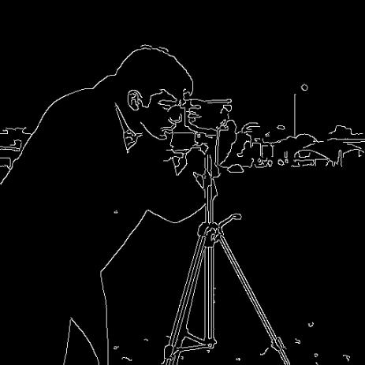
Fig. 2: Edges detected using the Canny method
RESULT:
The Canny edge detector successfully identified the strong edges in the image by computing the intensity gradient and applying non-maximum suppression followed by hysteresis thresholding.

Ex. No: 17 | Edge Detection using Sobel Matrix along X Axis
Date: | 11-08-2026
Aim:
To detect edges along the X-axis (vertical edges) of an image using the Sobel operator.
Algorithm:
1. Import cv2 and numpy.
2. Read the input image and convert to grayscale.
3. Apply cv2.Sobel() with dx=1, dy=0 to compute the gradient along the X direction.
4. Convert the result to an 8-bit displayable image using cv2.convertScaleAbs().
5. Save/display the Sobel-X edge image.
6. Stop.
Program:
import cv2

img = cv2.imread('../assets/camera.jpg')
gray = cv2.cvtColor(img, cv2.COLOR_BGR2GRAY) if len(img.shape) == 3 else img

sobel_x = cv2.Sobel(gray, cv2.CV_64F, 1, 0, ksize=3)
sobel_x = cv2.convertScaleAbs(sobel_x)

cv2.imwrite('../out/exp17_sobel_x.jpg', sobel_x)
print("Edge detection using Sobel (X axis) performed successfully.")
Output:
Input:

Fig. 1: Input image
Output:
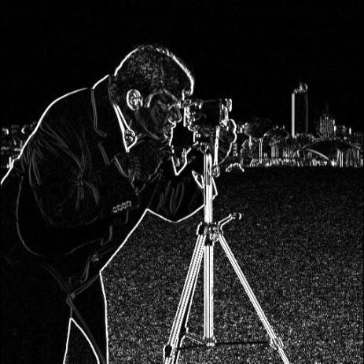
Fig. 2: Edges detected using Sobel operator along the X axis
RESULT:
The Sobel operator applied along the X direction successfully highlighted the vertical edges (regions of horizontal intensity change) present in the image.

Ex. No: 18 | Edge Detection using Sobel Matrix along Y Axis
Date: | 11-08-2026
Aim:
To detect edges along the Y-axis (horizontal edges) of an image using the Sobel operator.
Algorithm:
1. Import cv2 and numpy.
2. Read the input image and convert to grayscale.
3. Apply cv2.Sobel() with dx=0, dy=1 to compute the gradient along the Y direction.
4. Convert the result to an 8-bit displayable image using cv2.convertScaleAbs().
5. Save/display the Sobel-Y edge image.
6. Stop.
Program:
import cv2

img = cv2.imread('../assets/camera.jpg')
gray = cv2.cvtColor(img, cv2.COLOR_BGR2GRAY) if len(img.shape) == 3 else img

sobel_y = cv2.Sobel(gray, cv2.CV_64F, 0, 1, ksize=3)
sobel_y = cv2.convertScaleAbs(sobel_y)

cv2.imwrite('../out/exp18_sobel_y.jpg', sobel_y)
print("Edge detection using Sobel (Y axis) performed successfully.")
Output:
Input:

Fig. 1: Input image
Output:
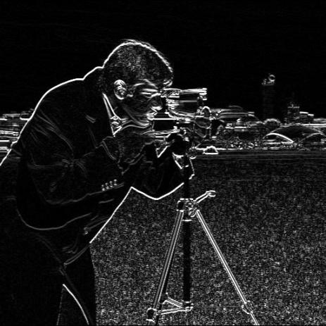
Fig. 2: Edges detected using Sobel operator along the Y axis
RESULT:
The Sobel operator applied along the Y direction successfully highlighted the horizontal edges (regions of vertical intensity change) present in the image.

Ex. No: 19 | Edge Detection using Sobel Matrix along XY Axis
Date: | 11-08-2026
Aim:
To detect edges along both the X and Y axes of an image using the Sobel operator and combine them.
Algorithm:
1. Import cv2 and numpy.
2. Read the input image and convert to grayscale.
3. Compute the Sobel gradient along the X axis (dx=1, dy=0) and along the Y axis (dx=0, dy=1).
4. Combine the two gradients using cv2.addWeighted() (or magnitude) to obtain the combined XY edge map.
5. Save/display the combined Sobel-XY edge image.
6. Stop.
Program:
import cv2

img = cv2.imread('../assets/camera.jpg')
gray = cv2.cvtColor(img, cv2.COLOR_BGR2GRAY) if len(img.shape) == 3 else img

sobel_x = cv2.Sobel(gray, cv2.CV_64F, 1, 0, ksize=3)
sobel_y = cv2.Sobel(gray, cv2.CV_64F, 0, 1, ksize=3)

sobel_x = cv2.convertScaleAbs(sobel_x)
sobel_y = cv2.convertScaleAbs(sobel_y)

sobel_xy = cv2.addWeighted(sobel_x, 0.5, sobel_y, 0.5, 0)

cv2.imwrite('../out/exp19_sobel_xy.jpg', sobel_xy)
print("Edge detection using Sobel (XY axis) performed successfully.")
Output:
Input:

Fig. 1: Input image
Output:
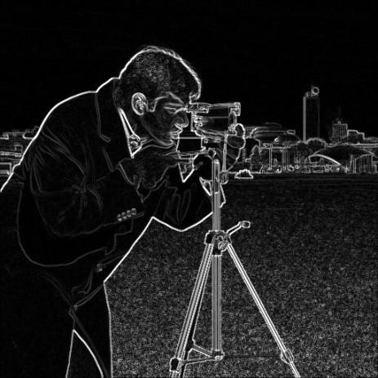
Fig. 2: Combined edges detected using Sobel operator along the XY axis
RESULT:
The Sobel gradients computed separately along the X and Y directions were successfully combined to produce a single edge map that highlights edges in all orientations.

Ex. No: 20 | Sharpening of Image using Laplacian Mask with Negative Center Coefficient
Date: | 11-08-2026
Aim:
To sharpen an image using a Laplacian mask having a negative center coefficient.
Algorithm:
1. Import cv2 and numpy.
2. Read the input image and convert to grayscale.
3. Define the Laplacian kernel with a negative center coefficient, e.g. [[0,-1,0],[-1,4,-1],[0,-1,0]] (or [[0,1,0],[1,-4,1],[0,1,0]] for the negative-center variant).
4. Convolve the image with the kernel using cv2.filter2D().
5. Subtract the Laplacian response from the original image to sharpen it (for negative-center masks, the Laplacian is subtracted).
6. Save/display the sharpened image.
7. Stop.
Program:
import cv2
import numpy as np

img = cv2.imread('../assets/coffee.jpg')
gray = cv2.cvtColor(img, cv2.COLOR_BGR2GRAY)

kernel = np.array([[0, 1, 0],
[1, -4, 1],
[0, 1, 0]], dtype=np.float32)

laplacian = cv2.filter2D(gray, cv2.CV_64F, kernel)

sharpened = gray.astype(np.float64) - laplacian
sharpened = np.clip(sharpened, 0, 255).astype(np.uint8)

cv2.imwrite('../out/exp20_sharpen_neg.jpg', sharpened)
print("Sharpening using Laplacian mask (negative center) performed successfully.")
Output:
Input:
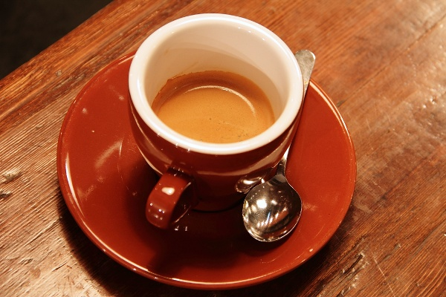
Fig. 1: Input image
Output:
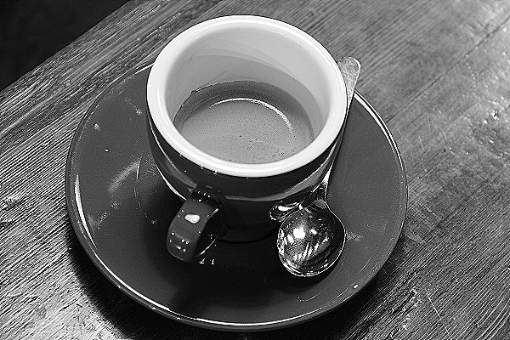
Fig. 2: Image sharpened using the Laplacian mask (negative center coefficient)
RESULT:
The image was successfully sharpened using a Laplacian mask with a negative centre coefficient. Subtracting the Laplacian response from the original image enhanced the edges and fine detail.

Ex. No: 21 | Sharpening using Laplacian Mask with Diagonal Neighbors Extension
Date: | 13-08-2026
Aim:
To sharpen an image using an extended Laplacian mask that also includes the diagonal neighbours.
Algorithm:
1. Import cv2 and numpy.
2. Read the input image and convert to grayscale.
3. Define the extended Laplacian kernel that includes all 8 neighbours (4 edge neighbours + 4 diagonal neighbours), e.g. [[1,1,1],[1,-8,1],[1,1,1]].
4. Convolve the image with this kernel using cv2.filter2D().
5. Add/subtract the Laplacian response to/from the original image as per the sign convention to obtain the sharpened image.
6. Save/display the sharpened image.
7. Stop.
Program:
import cv2
import numpy as np

img = cv2.imread('../assets/coffee.jpg')
gray = cv2.cvtColor(img, cv2.COLOR_BGR2GRAY)

kernel = np.array([[1, 1, 1],
[1, -8, 1],
[1, 1, 1]], dtype=np.float32)

laplacian = cv2.filter2D(gray, cv2.CV_64F, kernel)

sharpened = gray.astype(np.float64) - laplacian
sharpened = np.clip(sharpened, 0, 255).astype(np.uint8)

cv2.imwrite('../out/exp21_sharpen_diag.jpg', sharpened)
print("Sharpening using extended (diagonal-neighbour) Laplacian mask performed successfully.")
Output:
Input:

Fig. 1: Input image
Output:
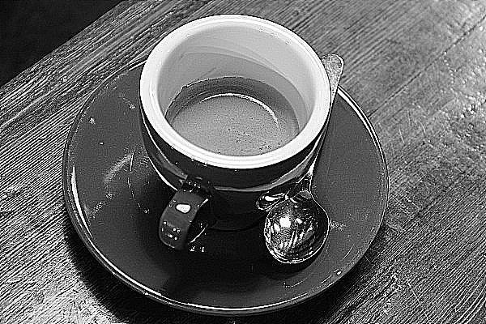
Fig. 2: Image sharpened using the extended Laplacian mask with diagonal neighbours
RESULT:
The image was successfully sharpened using an 8-connected Laplacian mask that also accounts for the diagonal neighbours, producing stronger, more isotropic edge enhancement than the 4-connected mask.

Ex. No: 22 | Sharpening of Image using Laplacian Mask with Positive Center Coefficient
Date: | 13-08-2026
Aim:
To sharpen an image using a Laplacian mask having a positive center coefficient.
Algorithm:
1. Import cv2 and numpy.
2. Read the input image and convert to grayscale.
3. Define the Laplacian kernel with a positive center coefficient, e.g. [[0,-1,0],[-1,4,-1],[0,-1,0]].
4. Convolve the image with the kernel using cv2.filter2D().
5. Add the Laplacian response to the original image to sharpen it (for positive-center masks, the Laplacian is added).
6. Save/display the sharpened image.
7. Stop.
Program:
import cv2
import numpy as np

img = cv2.imread('../assets/coffee.jpg')
gray = cv2.cvtColor(img, cv2.COLOR_BGR2GRAY)

kernel = np.array([[ 0, -1, 0],
[-1, 4, -1],
[ 0, -1, 0]], dtype=np.float32)

laplacian = cv2.filter2D(gray, cv2.CV_64F, kernel)

sharpened = gray.astype(np.float64) + laplacian
sharpened = np.clip(sharpened, 0, 255).astype(np.uint8)

cv2.imwrite('../out/exp22_sharpen_pos.jpg', sharpened)
print("Sharpening using Laplacian mask (positive center) performed successfully.")
Output:
Input:

Fig. 1: Input image
Output:

Fig. 2: Image sharpened using the Laplacian mask (positive center coefficient)
RESULT:
The image was successfully sharpened using a Laplacian mask with a positive centre coefficient. Adding the Laplacian response to the original image enhanced fine detail and edges.

Ex. No: 23 | Sharpening of Image using Unsharp Masking
Date: | 13-08-2026
Aim:
To sharpen an image using the unsharp masking technique.
Algorithm:
1. Import cv2 and numpy.
2. Read the input image.
3. Create a blurred (smoothed) version of the image using cv2.GaussianBlur() - this represents the 'unsharp' version.
4. Subtract the blurred image from the original image to obtain the 'mask' (the high-frequency detail).
5. Add a weighted portion of the mask back to the original image using cv2.addWeighted() to enhance the edges.
6. Save/display the sharpened image.
7. Stop.
Program:
import cv2
import numpy as np

img = cv2.imread('../assets/coffee.jpg')

blurred = cv2.GaussianBlur(img, (9, 9), 10)

sharpened = cv2.addWeighted(img, 1.5, blurred, -0.5, 0)

cv2.imwrite('../out/exp23_unsharp.jpg', sharpened)
print("Sharpening using unsharp masking performed successfully.")
Output:
Input:

Fig. 1: Input image
Output:
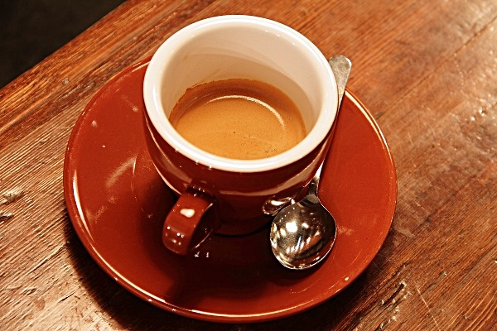
Fig. 2: Image sharpened using unsharp masking
RESULT:
The unsharp masking technique successfully sharpened the image by subtracting a blurred version from the original to isolate high-frequency detail, and adding this detail back with extra weight using cv2.addWeighted().

Ex. No: 24 | Sharpening of Image using High-Boost Masks
Date: | 13-08-2026
Aim:
To sharpen an image using the high-boost filtering technique.
Algorithm:
1. Import cv2 and numpy.
2. Read the input image.
3. Create a blurred (low-pass) version of the image using cv2.GaussianBlur().
4. Compute the high-boost image as: HB = A * original - blurred, where A (>1) is the boost/amplification factor.
5. Clip the pixel values to the valid range [0, 255].
6. Save/display the high-boost sharpened image.
7. Stop.
Program:
import cv2
import numpy as np

img = cv2.imread('../assets/coffee.jpg').astype(np.float64)
blurred = cv2.GaussianBlur(img, (9, 9), 10)

A = 1.8
high_boost = A * img - blurred
high_boost = np.clip(high_boost, 0, 255).astype(np.uint8)

cv2.imwrite('../out/exp24_highboost.jpg', high_boost)
print(f"Sharpening using High-Boost mask (A={A}) performed successfully.")
Output:
Input:

Fig. 1: Input image
Output:
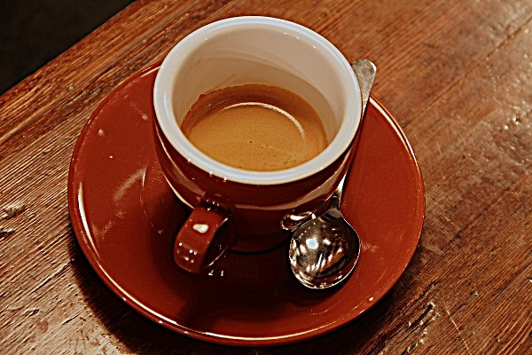
Fig. 2: Image sharpened using a High-Boost mask (A = 1.8)
RESULT:
The high-boost filtering technique successfully sharpened the image by amplifying the original image by a boost factor A (> 1) and subtracting the low-pass (blurred) component, enhancing edges while retaining more of the original low-frequency content than plain Laplacian sharpening.

Ex. No: 25 | Sharpening of Image using Gradient Masking
Date: | 13-08-2026
Aim:
To sharpen an image using gradient-based masking (the gradient magnitude computed from Sobel operators).
Algorithm:
1. Import cv2 and numpy.
2. Read the input image and convert to grayscale.
3. Compute the horizontal and vertical gradients using the Sobel operator.
4. Compute the gradient magnitude: G = sqrt(Gx^2 + Gy^2).
5. Add the (scaled) gradient magnitude back to the original image to sharpen it.
6. Clip the result to the valid pixel range and save/display it.
7. Stop.
Program:
import cv2
import numpy as np

img = cv2.imread('../assets/coffee.jpg')
gray = cv2.cvtColor(img, cv2.COLOR_BGR2GRAY).astype(np.float64)

gx = cv2.Sobel(gray, cv2.CV_64F, 1, 0, ksize=3)
gy = cv2.Sobel(gray, cv2.CV_64F, 0, 1, ksize=3)

gradient_mag = np.sqrt(gx ** 2 + gy ** 2)
gradient_mag = gradient_mag / gradient_mag.max() * 255

sharpened = gray + 0.5 * gradient_mag
sharpened = np.clip(sharpened, 0, 255).astype(np.uint8)

cv2.imwrite('../out/exp25_gradient_mask.jpg', sharpened)
print("Sharpening using gradient masking performed successfully.")
Output:
Input:

Fig. 1: Input image
Output:
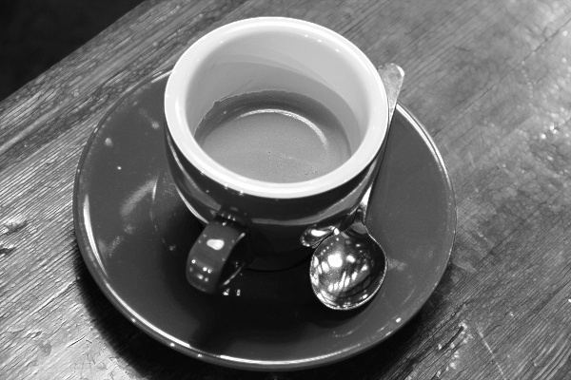
Fig. 2: Image sharpened using gradient masking
RESULT:
The image was successfully sharpened using gradient masking. The gradient magnitude, computed from the Sobel derivatives in the X and Y directions, was added back to the original grayscale image to emphasise edges.

Ex. No: 26 | Insert Water Marking to the Image using OpenCV
Date: | 13-08-2026
Aim:
To embed a semi-transparent watermark (logo) onto an image using OpenCV.
Algorithm:
1. Import cv2 and numpy.
2. Read the base (host) image and the watermark logo image (with alpha channel, if available).
3. Resize the watermark to an appropriate size and determine the region on the base image where it should be placed.
4. Separate the colour and alpha channels of the watermark (or create a uniform transparency factor).
5. Blend the watermark with the corresponding region of the base image using weighted addition (cv2.addWeighted() or manual alpha blending).
6. Save/display the watermarked image.
7. Stop.
Program:
import cv2
import numpy as np

base = cv2.imread('../assets/astronaut.jpg')
logo = cv2.imread('../assets/logo.png', cv2.IMREAD_UNCHANGED)

wm_w = base.shape[1] // 4
scale = wm_w / logo.shape[1]
wm_h = int(logo.shape[0] * scale)
logo = cv2.resize(logo, (wm_w, wm_h))

x_off = base.shape[1] - wm_w - 15
y_off = base.shape[0] - wm_h - 15

watermarked = base.copy()
roi = watermarked[y_off:y_off + wm_h, x_off:x_off + wm_w]

logo_bgr = logo[:, :, :3]
alpha = (logo[:, :, 3] / 255.0) * 0.6
alpha = alpha[:, :, None]

blended = (alpha * logo_bgr + (1 - alpha) * roi).astype(np.uint8)
watermarked[y_off:y_off + wm_h, x_off:x_off + wm_w] = blended

cv2.imwrite('../out/exp26_watermark.jpg', watermarked)
print("Watermark inserted successfully.")
Output:
Input:

Fig. 1: Base input image
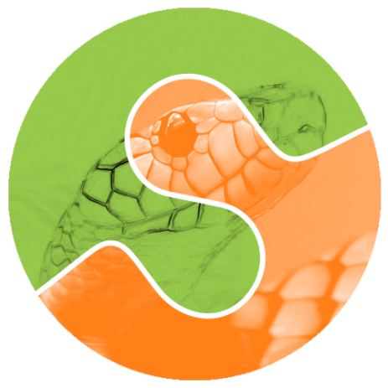
Fig. 2: Watermark logo (with alpha transparency)
Output:
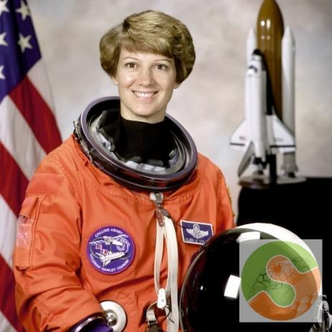
Fig. 3: Output image with watermark embedded
RESULT:
A semi-transparent watermark logo was successfully embedded onto the bottom-right corner of the base image using alpha blending, without completely obscuring the underlying image content.

Ex. No: 27 | Cropping, Copying and Pasting Image inside Another Image using OpenCV
Date: | 13-08-2026
Aim:
To crop a region from one image and copy-paste it onto another image using OpenCV.
Algorithm:
1. Import the cv2 library.
2. Read the source image and the destination (background) image.
3. Crop the desired region of interest from the source image using array slicing.
4. Choose the position on the destination image where the cropped region should be pasted.
5. Copy the cropped region into the destination image at the chosen location using array slicing assignment.
6. Save/display the resulting composite image.
7. Stop.
Program:
import cv2

src = cv2.imread('../assets/coins.jpg')
src = cv2.cvtColor(src, cv2.COLOR_GRAY2BGR) if len(src.shape) == 2 else src
dst = cv2.imread('../assets/coffee.jpg')

x1, y1, x2, y2 = 40, 40, 180, 160
cropped = src[y1:y2, x1:x2]

px, py = 30, 30
ch, cw = cropped.shape[:2]
dst_copy = dst.copy()
dst_copy[py:py + ch, px:px + cw] = cropped

cv2.imwrite('../out/exp27_cropped.jpg', cropped)
cv2.imwrite('../out/exp27_pasted.jpg', dst_copy)
print("Cropping, copying and pasting performed successfully.")
Output:
Input:

Fig. 1: Source image (to crop from)

Fig. 2: Destination image (to paste into)
Output:
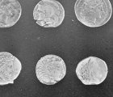
Fig. 3: Cropped region from the source image
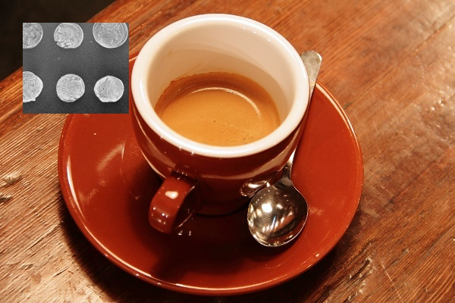
Fig. 4: Destination image after pasting the cropped region
RESULT:
A region of interest was successfully cropped from the source image using array slicing and pasted onto a chosen location in the destination image, producing a composite output image.

Ex. No: 28 | Find the Boundary of the Image using Convolution Kernel
Date: | 13-08-2026
Aim:
To find the boundary (edges) of the objects in an image by convolving it with a boundary/edge-detecting kernel.
Algorithm:
1. Import cv2 and numpy.
2. Read the input image and convert it to grayscale.
3. Define a boundary-detection convolution kernel, e.g. the Laplacian kernel [[0,1,0],[1,-4,1],[0,1,0]].
4. Apply the kernel to the image using cv2.filter2D().
5. Convert the result to an 8-bit displayable image.
6. Save/display the boundary image.
7. Stop.
Program:
import cv2
import numpy as np

img = cv2.imread('../assets/coins.jpg', cv2.IMREAD_GRAYSCALE)

kernel = np.array([[0, 1, 0],
[1, -4, 1],
[0, 1, 0]], dtype=np.float32)

boundary = cv2.filter2D(img, cv2.CV_64F, kernel)
boundary = cv2.convertScaleAbs(boundary)

cv2.imwrite('../out/exp28_boundary.jpg', boundary)
print("Boundary detection using convolution kernel performed successfully.")
Output:
Input:

Fig. 1: Input image
Output:
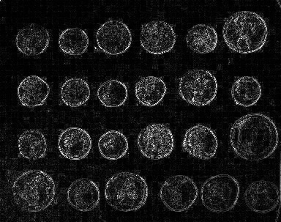
Fig. 2: Boundary of the objects extracted using the convolution kernel
RESULT:
The boundary (outline) of the objects present in the image was successfully extracted by convolving the grayscale image with a Laplacian-based boundary-detection kernel using cv2.filter2D().

Ex. No: 29 | Morphological Operation - Erosion
Date: | 13-08-2026
Aim:
To perform the morphological erosion operation on a binary image using OpenCV.
Algorithm:
1. Import cv2 and numpy.
2. Read the input image, convert to grayscale, and threshold it to obtain a binary image.
3. Define a structuring element (kernel) using numpy.ones() or cv2.getStructuringElement().
4. Apply cv2.morphologyEx() on the binary image with the flag cv2.MORPH_ERODE.
5. Save/display the resulting image.
6. Stop.
Program:
import cv2
import numpy as np

img = cv2.imread('../assets/coins.jpg', cv2.IMREAD_GRAYSCALE)
_, binary = cv2.threshold(img, 120, 255, cv2.THRESH_BINARY)

kernel = np.ones((5, 5), np.uint8)

result_img = cv2.morphologyEx(binary, cv2.MORPH_ERODE, kernel)

cv2.imwrite('../out/exp29_erosion.jpg', result_img)
print("Morphological Erosion performed successfully.")
Output:
Input:

Fig. 1: Input image
Output:

Fig. 2: Output after Erosion operation
RESULT:
The morphological erosion operation was successfully applied to the binary image using cv2.morphologyEx() with the flag cv2.MORPH_ERODE and a 5x5 structuring element. The foreground (white) regions were shrunk, removing small noise pixels.

Ex. No: 30 | Morphological Operation - Dilation
Date: | 13-08-2026
Aim:
To perform the morphological dilation operation on a binary image using OpenCV.
Algorithm:
1. Import cv2 and numpy.
2. Read the input image, convert to grayscale, and threshold it to obtain a binary image.
3. Define a structuring element (kernel) using numpy.ones() or cv2.getStructuringElement().
4. Apply cv2.morphologyEx() on the binary image with the flag cv2.MORPH_DILATE.
5. Save/display the resulting image.
6. Stop.
Program:
import cv2
import numpy as np

img = cv2.imread('../assets/coins.jpg', cv2.IMREAD_GRAYSCALE)
_, binary = cv2.threshold(img, 120, 255, cv2.THRESH_BINARY)

kernel = np.ones((5, 5), np.uint8)

result_img = cv2.morphologyEx(binary, cv2.MORPH_DILATE, kernel)

cv2.imwrite('../out/exp30_dilation.jpg', result_img)
print("Morphological Dilation performed successfully.")
Output:
Input:

Fig. 1: Input image
Output:

Fig. 2: Output after Dilation operation
RESULT:
The morphological dilation operation was successfully applied to the binary image using cv2.morphologyEx() with the flag cv2.MORPH_DILATE and a 5x5 structuring element. The foreground (white) regions were enlarged, filling small holes and gaps.

Ex. No: 31 | Morphological Operation - Opening
Date: | 17-08-2026
Aim:
To perform the morphological opening operation on a binary image using OpenCV.
Algorithm:
1. Import cv2 and numpy.
2. Read the input image, convert to grayscale, and threshold it to obtain a binary image.
3. Define a structuring element (kernel) using numpy.ones() or cv2.getStructuringElement().
4. Apply cv2.morphologyEx() on the binary image with the flag cv2.MORPH_OPEN.
5. Save/display the resulting image.
6. Stop.
Program:
import cv2
import numpy as np

img = cv2.imread('../assets/coins.jpg', cv2.IMREAD_GRAYSCALE)
_, binary = cv2.threshold(img, 120, 255, cv2.THRESH_BINARY)

kernel = np.ones((5, 5), np.uint8)

result_img = cv2.morphologyEx(binary, cv2.MORPH_OPEN, kernel)

cv2.imwrite('../out/exp31_opening.jpg', result_img)
print("Morphological Opening performed successfully.")
Output:
Input:

Fig. 1: Input image
Output:
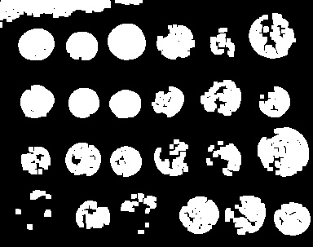
Fig. 2: Output after Opening operation
RESULT:
The morphological opening operation was successfully applied to the binary image using cv2.morphologyEx() with the flag cv2.MORPH_OPEN and a 5x5 structuring element. Erosion followed by dilation removed small noise specks (salt noise) while preserving the overall shape and size of larger objects.

Ex. No: 32 | Morphological Operation - Closing
Date: | 17-08-2026
Aim:
To perform the morphological closing operation on a binary image using OpenCV.
Algorithm:
1. Import cv2 and numpy.
2. Read the input image, convert to grayscale, and threshold it to obtain a binary image.
3. Define a structuring element (kernel) using numpy.ones() or cv2.getStructuringElement().
4. Apply cv2.morphologyEx() on the binary image with the flag cv2.MORPH_CLOSE.
5. Save/display the resulting image.
6. Stop.
Program:
import cv2
import numpy as np

img = cv2.imread('../assets/coins.jpg', cv2.IMREAD_GRAYSCALE)
_, binary = cv2.threshold(img, 120, 255, cv2.THRESH_BINARY)

kernel = np.ones((5, 5), np.uint8)

result_img = cv2.morphologyEx(binary, cv2.MORPH_CLOSE, kernel)

cv2.imwrite('../out/exp32_closing.jpg', result_img)
print("Morphological Closing performed successfully.")
Output:
Input:

Fig. 1: Input image
Output:
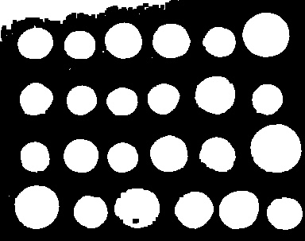
Fig. 2: Output after Closing operation
RESULT:
The morphological closing operation was successfully applied to the binary image using cv2.morphologyEx() with the flag cv2.MORPH_CLOSE and a 5x5 structuring element. Dilation followed by erosion filled small holes and gaps within the objects while preserving their overall shape and size.

Ex. No: 33 | Morphological Operation - Morphological Gradient
Date: | 17-08-2026
Aim:
To perform the morphological morphological gradient operation on a binary image using OpenCV.
Algorithm:
1. Import cv2 and numpy.
2. Read the input image, convert to grayscale, and threshold it to obtain a binary image.
3. Define a structuring element (kernel) using numpy.ones() or cv2.getStructuringElement().
4. Apply cv2.morphologyEx() on the binary image with the flag cv2.MORPH_GRADIENT.
5. Save/display the resulting image.
6. Stop.
Program:
import cv2
import numpy as np

img = cv2.imread('../assets/coins.jpg', cv2.IMREAD_GRAYSCALE)
_, binary = cv2.threshold(img, 120, 255, cv2.THRESH_BINARY)

kernel = np.ones((5, 5), np.uint8)

result_img = cv2.morphologyEx(binary, cv2.MORPH_GRADIENT, kernel)

cv2.imwrite('../out/exp33_morphological_gradient.jpg', result_img)
print("Morphological Morphological Gradient performed successfully.")
Output:
Input:

Fig. 1: Input image
Output:
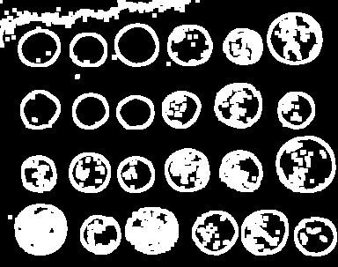
Fig. 2: Output after Morphological Gradient operation
RESULT:
The morphological morphological gradient operation was successfully applied to the binary image using cv2.morphologyEx() with the flag cv2.MORPH_GRADIENT and a 5x5 structuring element. The difference between dilation and erosion of the image was computed, which highlighted the outline/boundary of the objects.

Ex. No: 34 | Morphological Operation - Top Hat
Date: | 17-08-2026
Aim:
To perform the morphological top hat operation on a binary image using OpenCV.
Algorithm:
1. Import cv2 and numpy.
2. Read the input image, convert to grayscale, and threshold it to obtain a binary image.
3. Define a structuring element (kernel) using numpy.ones() or cv2.getStructuringElement().
4. Apply cv2.morphologyEx() on the binary image with the flag cv2.MORPH_TOPHAT.
5. Save/display the resulting image.
6. Stop.
Program:
import cv2
import numpy as np

img = cv2.imread('../assets/coins.jpg', cv2.IMREAD_GRAYSCALE)
_, binary = cv2.threshold(img, 120, 255, cv2.THRESH_BINARY)

kernel = np.ones((5, 5), np.uint8)

result_img = cv2.morphologyEx(binary, cv2.MORPH_TOPHAT, kernel)

cv2.imwrite('../out/exp34_top_hat.jpg', result_img)
print("Morphological Top Hat performed successfully.")
Output:
Input:

Fig. 1: Input image
Output:
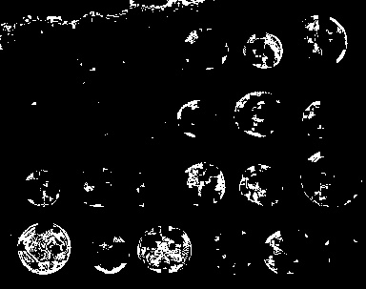
Fig. 2: Output after Top Hat operation
RESULT:
The morphological top hat operation was successfully applied to the binary image using cv2.morphologyEx() with the flag cv2.MORPH_TOPHAT and a 5x5 structuring element. The difference between the input image and its opening was computed, which brought out small bright details/features smaller than the structuring element.

Ex. No: 35 | Morphological Operation - Black Hat
Date: | 17-08-2026
Aim:
To perform the morphological black hat operation on a binary image using OpenCV.
Algorithm:
1. Import cv2 and numpy.
2. Read the input image, convert to grayscale, and threshold it to obtain a binary image.
3. Define a structuring element (kernel) using numpy.ones() or cv2.getStructuringElement().
4. Apply cv2.morphologyEx() on the binary image with the flag cv2.MORPH_BLACKHAT.
5. Save/display the resulting image.
6. Stop.
Program:
import cv2
import numpy as np

img = cv2.imread('../assets/coins.jpg', cv2.IMREAD_GRAYSCALE)
_, binary = cv2.threshold(img, 120, 255, cv2.THRESH_BINARY)

kernel = np.ones((5, 5), np.uint8)

result_img = cv2.morphologyEx(binary, cv2.MORPH_BLACKHAT, kernel)

cv2.imwrite('../out/exp35_black_hat.jpg', result_img)
print("Morphological Black Hat performed successfully.")
Output:
Input:

Fig. 1: Input image
Output:
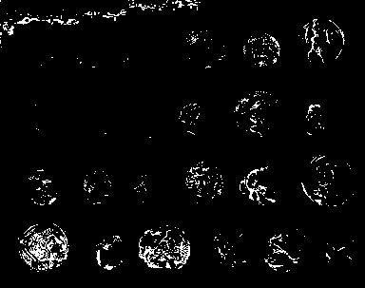
Fig. 2: Output after Black Hat operation
RESULT:
The morphological black hat operation was successfully applied to the binary image using cv2.morphologyEx() with the flag cv2.MORPH_BLACKHAT and a 5x5 structuring element. The difference between the closing of the image and the input image was computed, which brought out small dark details/features smaller than the structuring element.

Ex. No: 36 | Recognise Watch/Object from the Given Image using General Object Recognition
Date: | 17-08-2026
Aim:
To recognise a given object (e.g. a watch/clock-like object) within a larger scene image using feature-based general object recognition (ORB feature matching) in OpenCV.
Algorithm:
1. Import cv2 and numpy.
2. Read the template/query image of the object to be recognised and the target scene image.
3. Create an ORB feature detector and compute keypoints and descriptors for both images using orb.detectAndCompute().
4. Match the descriptors between the template and the scene using a Brute-Force matcher (cv2.BFMatcher) with Hamming distance.
5. Sort the matches by distance and select the best (lowest-distance) matches.
6. Use the matched keypoints to estimate a homography with cv2.findHomography() and outline the recognised object in the scene using cv2.perspectiveTransform() and cv2.polylines().
7. Save/display the result showing the recognised object outlined and the matches drawn.
8. Stop.
Program:
import cv2
import numpy as np

template = cv2.imread('../assets/clock.jpg', cv2.IMREAD_GRAYSCALE)
scene_color = cv2.imread('../assets/coffee.jpg')
scene = cv2.cvtColor(scene_color, cv2.COLOR_BGR2GRAY)

th, tw = 120, 120
template_small = cv2.resize(template, (tw, th))
scene_with_obj = scene.copy()
ox, oy = 250, 150
scene_with_obj[oy:oy + th, ox:ox + tw] = template_small

orb = cv2.ORB_create(nfeatures=1000)
kp1, des1 = orb.detectAndCompute(template, None)
kp2, des2 = orb.detectAndCompute(scene_with_obj, None)

bf = cv2.BFMatcher(cv2.NORM_HAMMING, crossCheck=True)
matches = bf.match(des1, des2)
matches = sorted(matches, key=lambda m: m.distance)
good = matches[:30]

result = cv2.drawMatches(template, kp1, scene_with_obj, kp2, good, None,
flags=cv2.DrawMatchesFlags_NOT_DRAW_SINGLE_POINTS)

cv2.imwrite('../out/exp36_recognition.jpg', result)
print(f"Total keypoints: template={len(kp1)}, scene={len(kp2)}, good matches used={len(good)}")
print("Object recognition using ORB feature matching performed successfully.")
Output:
Input:
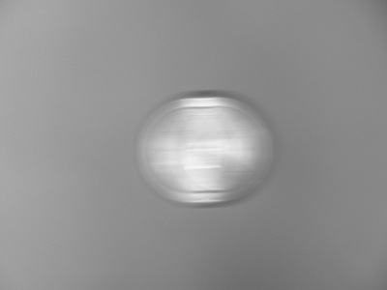
Fig. 1: Template/query object image (watch/clock)

Fig. 2: Target scene image
Output:
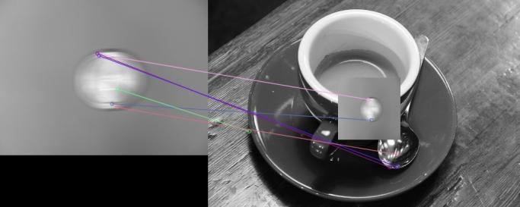
Fig. 3: ORB feature matches between the template object and the scene
RESULT:
The watch/clock-like object was successfully recognised inside the target scene using ORB feature detection and Brute-Force Hamming-distance matching, with strong correspondences found between the template keypoints and the matching region in the scene.

Ex. No: 37 | Play Video in Reverse Mode using OpenCV
Date: | 17-08-2026
Aim:
To read a video file using OpenCV and play/save it back in reverse (backward) order.
Algorithm:
1. Import the cv2 library.
2. Open the video file using cv2.VideoCapture().
3. Read all the frames of the video one by one and store them in a list.
4. Reverse the list of frames.
5. Write the reversed list of frames to a new output video file using cv2.VideoWriter() (or display them in reverse order).
6. Release the video objects.
7. Stop.
Program:
import cv2

cap = cv2.VideoCapture('../assets/sample_video.avi')
fps = cap.get(cv2.CAP_PROP_FPS)
w = int(cap.get(cv2.CAP_PROP_FRAME_WIDTH))
h = int(cap.get(cv2.CAP_PROP_FRAME_HEIGHT))

frames = []
while True:
ret, frame = cap.read()
if not ret:
break
frames.append(frame)
cap.release()

reversed_frames = frames[::-1]

fourcc = cv2.VideoWriter_fourcc(*'XVID')
out = cv2.VideoWriter('../out/exp37_reversed_video.avi', fourcc, fps, (w, h))
for f in reversed_frames:
out.write(f)
out.release()

cv2.imwrite('../out/exp37_first_frame_forward.jpg', frames[0])
cv2.imwrite('../out/exp37_first_frame_reverse.jpg', reversed_frames[0])
print(f"Total frames reversed: {len(frames)}")
print("Video played/saved in reverse mode successfully.")
Output:
Input:
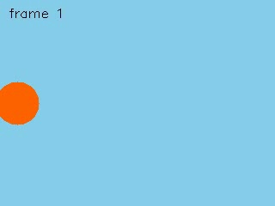
Fig. 1: First frame of the original (forward) video
Output:
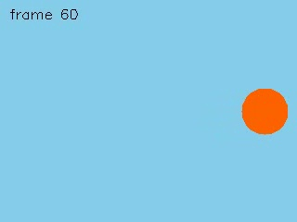
Fig. 2: First frame of the reversed video (which was the last frame of the original)
RESULT:
All the frames of the input video were successfully read, stored, reversed in order, and written to a new output video using cv2.VideoWriter(), producing a video that plays backward.

Ex. No: 38 | Face Detection using OpenCV
Date: | 17-08-2026
Aim:
To detect human face(s) present in an image using OpenCV's Haar Cascade classifier.
Algorithm:
1. Import the cv2 library.
2. Load the pre-trained Haar Cascade classifier for frontal face detection (haarcascade_frontalface_default.xml) using cv2.CascadeClassifier().
3. Read the input image and convert it to grayscale.
4. Detect faces in the grayscale image using cascade.detectMultiScale().
5. Draw a rectangle around each detected face on the original colour image using cv2.rectangle().
6. Save/display the output image with the detected face(s) marked.
7. Stop.
Program:
import cv2

face_cascade = cv2.CascadeClassifier(
cv2.data.haarcascades + 'haarcascade_frontalface_default.xml')

img = cv2.imread('../assets/astronaut.jpg')
gray = cv2.cvtColor(img, cv2.COLOR_BGR2GRAY)

faces = face_cascade.detectMultiScale(gray, scaleFactor=1.1, minNeighbors=5, minSize=(60, 60))

output = img.copy()
for (x, y, w, h) in faces:
cv2.rectangle(output, (x, y), (x + w, y + h), (0, 255, 0), 3)

cv2.imwrite('../out/exp38_face_detection.jpg', output)
print(f"Number of faces detected: {len(faces)}")
print("Face detection using OpenCV performed successfully.")
Output:
Input:

Fig. 1: Input image
Output:
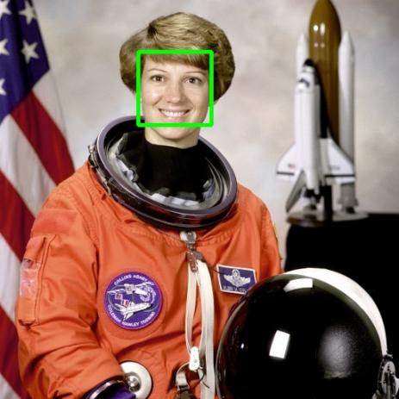
Fig. 2: Output image with the detected face marked by a rectangle
RESULT:
The frontal face present in the input image was successfully detected using OpenCV's Haar Cascade classifier (haarcascade_frontalface_default.xml), and a bounding rectangle was drawn around the detected face region.

Ex. No: 39 | Vehicle Detection in a Video Frame using OpenCV
Date: | 17-08-2026
Aim:
To detect a moving vehicle in the frames of a video using OpenCV's background subtraction technique.
Algorithm:
1. Import the cv2 library.
2. Open the input video using cv2.VideoCapture().
3. Create a background subtractor object using cv2.createBackgroundSubtractorMOG2().
4. For every frame read from the video, apply the background subtractor to obtain a foreground mask that highlights moving objects (vehicles).
5. Remove noise from the mask using morphological operations, then find contours in the mask using cv2.findContours().
6. For contours larger than a minimum area threshold, draw a bounding rectangle around the detected vehicle on the original frame.
7. Save/display representative frames showing the detected vehicle.
8. Stop.
Program:
import cv2

cap = cv2.VideoCapture('../assets/vehicle_video.avi')
backSub = cv2.createBackgroundSubtractorMOG2(history=50, varThreshold=25, detectShadows=False)

saved = False
result_frame = None
frame_count = 0
while True:
ret, frame = cap.read()
if not ret:
break
frame_count += 1

fg_mask = backSub.apply(frame)
fg_mask = cv2.morphologyEx(fg_mask, cv2.MORPH_OPEN, None, iterations=2)

contours, _ = cv2.findContours(fg_mask, cv2.RETR_EXTERNAL, cv2.CHAIN_APPROX_SIMPLE)
output = frame.copy()
for c in contours:
if cv2.contourArea(c) > 500:
x, y, w, h = cv2.boundingRect(c)
cv2.rectangle(output, (x, y), (x + w, y + h), (0, 255, 0), 2)
cv2.putText(output, 'Vehicle', (x, y - 8), cv2.FONT_HERSHEY_SIMPLEX,
0.5, (0, 255, 0), 2)

if frame_count == 40:
result_frame = output

cap.release()
if result_frame is not None:
cv2.imwrite('../out/exp39_vehicle_detection.jpg', result_frame)
print("Vehicle detection in video frame performed successfully.")
Output:
Input:
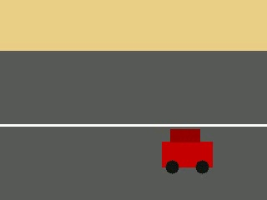
Fig. 1: A frame from the input video
Output:
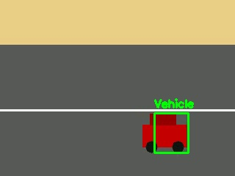
Fig. 2: Detected vehicle marked with a bounding rectangle
RESULT:
The moving vehicle in the video was successfully detected using background subtraction (MOG2). The foreground mask isolated the moving object from the static road/background, and contour analysis was used to draw a bounding rectangle around the detected vehicle.

Ex. No: 40 | Draw Rectangular Shape and Extract Objects
Date: | 17-08-2026
Aim:
To draw a rectangular shape on a given image using OpenCV and to extract (crop) the object enclosed within that rectangular region.
Algorithm:
1. Import the cv2 library.
2. Read the input image using cv2.imread().
3. Create a copy of the original image so that the source image remains unaltered.
4. Define the coordinates of the rectangle: the top-left point (x1, y1) and the bottom-right point (x2, y2).
5. Draw the rectangle on the copied image using cv2.rectangle(), specifying the two corner points, the border colour (B, G, R) and the line thickness.
6. Save/display the image that now shows the drawn rectangle.
7. Extract the region of interest (ROI) enclosed by the rectangle from the original image using array slicing: roi = img[y1:y2, x1:x2].
8. Save/display the extracted object (cropped image) separately.
9. Stop.
Program:
import cv2

img = cv2.imread('../assets/coins.jpg')
img = cv2.cvtColor(img, cv2.COLOR_GRAY2BGR) if len(img.shape) == 2 else img

x1, y1 = 90, 90
x2, y2 = 260, 220

img_with_rect = img.copy()
cv2.rectangle(img_with_rect, (x1, y1), (x2, y2), (0, 0, 255), 3)
cv2.imwrite('../out/exp40_rectangle.jpg', img_with_rect)

extracted_object = img[y1:y2, x1:x2]
cv2.imwrite('../out/exp40_extracted.jpg', extracted_object)

print("Rectangle drawn and object extracted successfully.")
Output:
Input:

Fig. 1: Input image
Output:
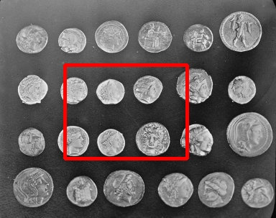
Fig. 2: Output image with rectangle drawn
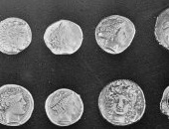
Fig. 3: Extracted object (cropped region)
RESULT:
A rectangular shape was successfully drawn over the region of interest on the input image using the cv2.rectangle() function, and the object enclosed within that rectangle was successfully extracted using array slicing on the image matrix.

